1. **Proposed Solution:**

To implement a solution for air pollution monitoring using Drone technology, we have to consider two main aspects. 1) Hardware configuration and 2) its control process. In our project we have designed our drone with multipurpose using different sensors. First of all, we thought in the context of Dhaka city. As the air of Dhaka is full of pollutant and we all know how many side effects it has, so our first step was to detect those pollutants from air, pollutants intensity of different area. We used GPS technology system so that our drone can perform automatically. Next step is to collect those data and analyses it. After analyzing data, we would know and compare the values where there is more pollutants which caused different hazards. So, clean the air our motive is to use air filter. As a result, our drone can automatically filter the air from toxic elements. We will use “Hepa mini”, a small air filter device. This drone can be used for research purpose and study of air quality. We used DJIF450 Quadcopter frame to build drone.

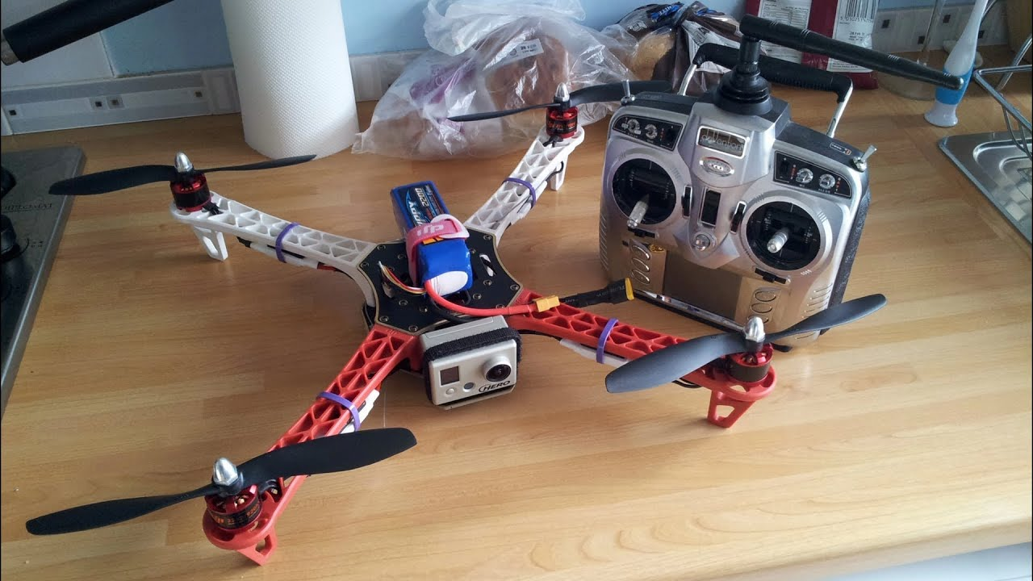Fig: 15 Drone

By following these guides, our proposal can also be split into three parts.

1. Making Drone
2. Integrating Sensors and installation of pi cam
3. Analysing data.